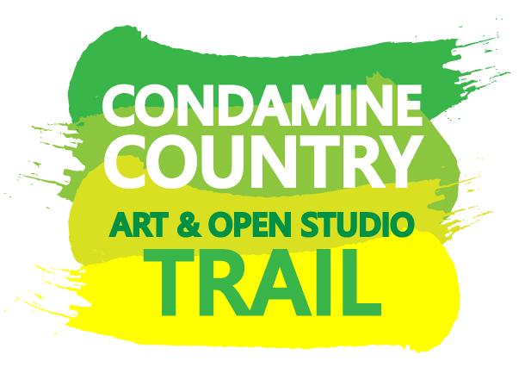

ARTISAN APPLICATION

CONDAMINE COUNTRY ART AND OPEN STUDIO TRAIL 5 – 6 NOVEMBER 2022

WHAT IS AN ARTS TRAIL?
Basically it is a publication with a map showing information about artisans and venues including their locations so visitors can plan their own “adventure”. The idea is for people to use this booklet to create their own adventure across the advertised days/times in November.

WHAT IS AN OPEN STUDIO?
An ‘Open Studio’ is when artisans “on the Arts Trail” commit to inviting the public into their studios to experience their art or craft process by way of a demonstration, workshop or discussion about their art or craft. Visitors LOVE the real studio experience and, when we assess the applications, preference is given to authentic and interesting studios. Your studio doesn’t have to be pretty or pristine. If you don’t have a studio at home, we are planning a pop up opportunity at the Warwick Art Gallery on Sunday 6 November. This opportunity will be open to six local artists. You can apply to be part of the pop up event using this application form as well.

IT IS CRUCIAL THAT THE ARTISAN OFFERS AN EXPEREINCE – SOMETHING DIFFERENT AND MEMORABLE – SO OUR VISITORS FEEL THAT THEY HAVE SEEN SOMETHING NOT NORMALLY MADE PUBLIC. IT NEEDS TO BE MORE THAN AN ART EXHIBITION.

WHO CAN APPLY?
Artisans residing on the Southern Downs north of Dalveen. Unfortunately we cannot extend the trail beyond the boundary of the Southern Downs Regional Council. NOTE YOU MAY BE ASKED TO PROVIDE PROOF OF RESIDENTIAL ADDRESS.

PAYMENTS

Individual artisans who are accepted to be on the 2022 Condamine Country Art and Open Studio Trail will be paid an artist fee of $500.

Artists who apply for the pop up studio event at Warwick Art Gallery will receive a payment of $200

To support the sustainability of the projects artists are required to submit a written report (template provided) with details about visitor numbers, feedback, suggestions and sales. CCART request a 10% commission is paid to Warwick Art Gallery for income received from artwork sales and workshop fees made on the two days of the trail only. Artists selected for the pop up event at Warwick Art Gallery will also be required to submit the report and pay the 10% commission. Sales made after the trail incur no commission.

CONDITIONS

An Artisan must be in attendance and “demonstrating” their art/craft, during the hours advertised on both days of the CCART weekend. We highly recommend that you arrange to have support with you on the day so you can work on your art while they engage with the visitors.

The Artisan is responsible for making their own arrangements for their studio location. We are very keen for to highlight the authenticity of our Studio Trail – preference given to applicants who fit this criteria i.e. it is the studio that you typically do your artwork in.

The artisan must provide evidence of current public liability insurance.

The objective of this event is to provide visitors with an engaging experience and insight into the process of your chosen media/genre – it is more than a static art exhibition – it is an engagement event! We want your visitors to have a memorable experience involving conversation and discovery. Our analysis of the 2020/2021 CCARTs was that visitors were just as satisfied with a conversation and a demonstration as a more organized workshop – so don’t feel that you need to schedule a workshop to be involved.

Criteria for Selection will include:
- Membership of Warwick Art Gallery Inc
- Like and Follow CCART trail Facebook page
- Standard of work, and adequate body of work to display
- Authentic studio experience
- Visitor engagement activity planned
- Program preparedness
- Current Public Liability certificate of insurance from either your own business or the property where you will be demonstrating – this is a commercial arrangement you need to discuss with the owner of the property if you don’t have your own insurance – Flying Arts.com is one option but you need to make your own commercial/risk decision.
- To keep the Trail fresh and encourage repeat visitation, artists who have been part of the 2020 and 2021 CCART may not be accepted for the 2022 CCART.

SCHEDULE 2022
Thursday 26 May 2022 | Applications open
Thursday 22 July 2022 | Applications close
Tuesday 9 August 2022 | Successful applicants will be notified
September 2021 | Flyers produced and distributed
Saturday 5 and Sunday 6 November 2022 | CCART Trail weekend
Saturday 5 November 2022 | CCART Dinner

OPEN STUDIO EVENT APPLICATION

APPLICATIONS CLOSE 4PM THURSDAY 22 JULY 2022.
SUBMIT IN PERSON/BY POST/BY EMAIL

PART A – PARTICIPANT AGREEMENT

I, _______________________________________ (print name) would like to apply to participate in the CCART OPEN STUDIO EVENT 2022.

I will open my home based studio
I will arrange a venue as a temporary location for my studio
I am applying to be part of the Pop Up event at Warwick Art Gallery on Sunday 6 November

I/We commit to being open to the public from 9am – 4pm on the appropriate day/s.
I/we consent to images provided being used for promotional purposes.
I verify that all information provided to CCART is true and correct to the best of my/our knowledge. NOTE IF YOU HAVE ARRANGEMENTS WITH A VENUE YOU MUST HAVE THEIR SIGNATURE ON THIS APPLICATION TOO.

______________________________________________ ______________________________________________
Artisan Venue (If not a home based studio)

PART B - APPLICANT CONTACT DETAILS (ARTISAN)

Full Name
Address (artisan)
City |  | State |  | Postcode
Phone |  | Email

PART C – PROMOTION AND SOCIAL MEDIA

Website
Facebook
Instagram

PART D – ARTIST DETAILS

- Artisans - the following information is used in the printed trail booklet, newsletters, facebook and web posts and can’t be changed after your application has been processed.
- Please ensure images show what visitors can expect on the trail; a min of 1MB. Name your images like this before you upload “artistname1”, “artistname2”, “artistname3” and so on.

Full Name
Art Form or Media
Email
Phone Number
Artist Bio(200 word maximum)
Image 1 details
Image 2 details
Image 3 details
Image 4 details
Public Liability Insurance Policy Details
PART E – VISITOR ENGAGEMENT ACTIVITY – YOUR OFFERING

If you are creating events with costs/fixed start times, please make sure you have your booking process ready to go on your own social media site before we start promoting you. We will help to promote the link to anything you give us but we do not look after your bookings.

Description of activity
(200 word maximum)

Provide details including
- How to register
- Cost
- Things to bring

Example: “Miss Jane and Mr Squiqqle will offer two x 2 hour workshops on “texturing techniques” starting at 10am and 2pm each day. $30 includes all materials, tea and coffee, and instruction by Ima Artist. BYO play clothes and waterbottles. Numbers are capped to a max of 10 people, phone Ms SteamShovel to book on 0412345678 before 20 Oct 2020”

PART F – DESCRIBE YOUR STUDIO OR VENUE – DO NOT COMPETE IF APPLYING FOR THE POP UP EVENT AT WARWICK ART GALLERY

Address
City
State and Post Code
Phone
Email
(200 words maximum)
Things to consider:
- Accessibility of location including facilities (toilets, parking, guest areas)
- nearby places of interest
- Unique location marker – i.e. red letterbox or green flag

This section is to help inform trail visitors so they can plan their day/time and will not affect the application’s assessment.

Please make sure you have discussed your plans for this event with your neighbours.

SUBMISSION/APPLICATION CHECKLIST | TICK
PART A – signed by applicant AND authorized owner of venue (if not yours)
PART B - details completed by artisan

PART C – ARTISAN website, Facebook or other social media links
(like and follow CCARTtrail)

PART D – for each artisan, bio, social media links, 4 quality landscape 1MB pixel images of work that will be on the trail and current insurance
PART E – max 200 words about the engagement events to be offered.

PART F – max 200 words about the venue

GOOD LUCK WITH YOUR APPLICATION!

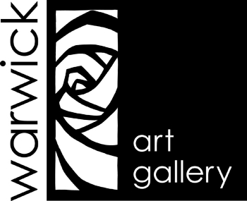

CCART is coordinated by Warwick Art Gallery
PO Box 775
49 Albion Street
Warwick QLD 4370
07 4661 0434
warwickart@sdrc.qld.gov.au

